Newhaven Fishwife
David Octavius Hill, Robert Adamson | ca. 1843–47 | Record IMG-NE0014

1. Original Image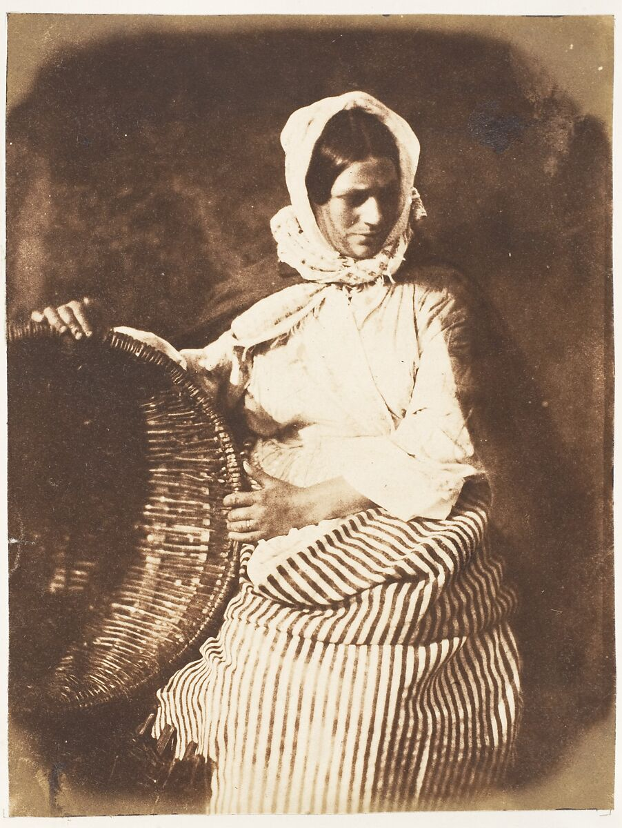
IMG-WA0013. David Octavius Hill, Robert Adamson, Newhaven Fishwife, Salted paper print from paper negative, ca. 1843–47. The Metropolitan Museum of Art.

2. Record Summary
Record ID | IMG-NE0014
Original title | Newhaven Fishwife
English title | Newhaven Fishwife
Alternative title | N/A
Creator | David Octavius Hill and Robert Adamson
Creation date | ca. 1843–47
Country | Scotland
Cultural region | Northern Europe; Newhaven, Edinburgh
Historical period | Victorian Scotland; early calotype photography
Image type | Photography
Medium | Salted paper print from paper negative
Dimensions | Not verified
Primary subject | Seated adult woman beside a wicker basket
Secondary subjects | Head covering, striped skirt and dark backdrop
Source institution | The Metropolitan Museum of Art
Collection or object number (optional) | 37.98.1.63

3. Image Description

3.1 Short Description
A seated adult woman faces the camera beside a large woven basket. She wears a light head covering and blouse with a strongly striped skirt. Her hands rest on or near the basket, and bright illumination separates her figure from a dark background.

3.2 Detailed Visual Description
The woman sits slightly right of centre. Her upper body turns toward the camera, while the striped skirt angles across the lower frame. A light cloth covers her head and wraps around the sides of her face and shoulders. A large wicker basket rises beside her, reaching approximately waist height.
Strong light illuminates the head covering, face, blouse and basket, while the surrounding backdrop remains very dark. The repeated dark and light stripes of the skirt form the strongest pattern in the image. No additional people, animals, architecture or written text are visible.

4. Formal Features
Field | Analysis
Composition | Asymmetrical triangular grouping of sitter and basket.
Viewpoint or camera angle | Near seated eye level.
Shot scale | Three-quarter seated portrait.
Spatial depth | Shallow.
Lighting | Strong directional illumination.
Colour palette | Warm cream, brown and near-black.
Contrast | High.
Visual focus | Face, head covering and basket.
Texture | Woven basket and striped textiles.
Movement or stillness | Sustained stationary pose.
Medium-specific features | Matte surface, soft contours and broad shadows associated with paper-negative photography.

5. Historical Context and Purpose

5.1 Historical Context
Hill and Adamson worked together in Edinburgh during the 1840s, using paper negatives and salted paper prints. Their Newhaven photographs represent sustained attention to a working community rather than conventional elite portraiture. The sitter’s occupation is supplied by the historical title and should not be inferred exclusively from the basket or clothing.
5.2 Image Purpose and Circulation
Original purpose: Not verified.
Probable purpose: Artistic and social portraiture within the photographers’ study of Newhaven residents.
Current institutional use: Interpretation of early portrait photography, labour and dress.

